38.14: a) The threshold frequency is found by setting V = 0 in Eq. (40.4), 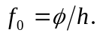
b) 